Lab Report-6

(Sanchit jalan,Group-3,2022101070,Table No:-40)

Experiment 5C:-

Objective:- To make 4 bit UP-DOWN counter.

Electronic components required:-

1. Arduino UNO
2. Digital test kit
3. Wires

TinkerCAD reference circuit:-

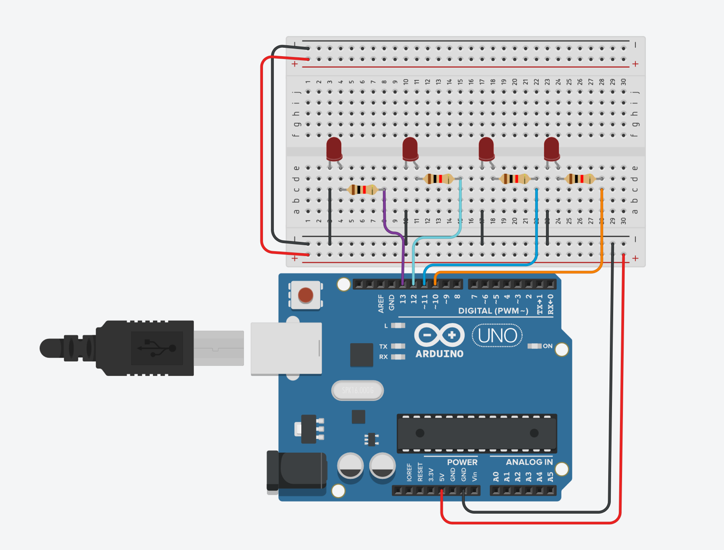

Procedure:-

1. Connect 4 pins of Arduino with 4 LEDS and connect power supply and ground of Arduino to breadboard.
2. Write the appropriate code for programming Arduino.
3. Most of the code was provided , we just had to program the code to make it oscillate from 0 to 15 and 15 to 0 .

Observation:-

1. First the counter goes up from 0 to 15 then the counter goes down from 15 to 0 ..It oscillates like this again and again ..

Arduino Code:-

Timer t;

int p0 = 10;

int p1 = 11, p2 = 12, p3 = 13;

int f = 1;

void setup()

{

Serial.begin(9600);

pinMode(p0, OUTPUT);

pinMode(p1, OUTPUT);

pinMode(p2, OUTPUT);

pinMode(p3, OUTPUT);

digitalWrite(p0, LOW);

digitalWrite(p1, LOW);

digitalWrite(p2, LOW);

digitalWrite(p3, LOW);

osc();

t.every(8010, osc);

}

void loop()

{

t.update();

}

int eventid0, eventid1, eventid2, eventid3;

void stopAllTimers()

{

t.stop(eventid0);

t.stop(eventid1);

t.stop(eventid2);

t.stop(eventid3);

}

void osc()

{

if (f == 0)

{

stopAllTimers();

eventid0 = t.oscillate(p0, 500, HIGH);

eventid1 = t.oscillate(p1, 1000, HIGH);

eventid2 = t.oscillate(p2, 2000, HIGH);

eventid3 = t.oscillate(p3, 4000, HIGH);

f = 1;

}

else if(f == 1)

{

stopAllTimers();

eventid0 = t.oscillate(p0, 500, LOW);

eventid1 = t.oscillate(p1, 1000, LOW);

eventid2 = t.oscillate(p2, 2000, LOW);

eventid3 = t.oscillate(p3, 4000, LOW);

f = 0;

}

}

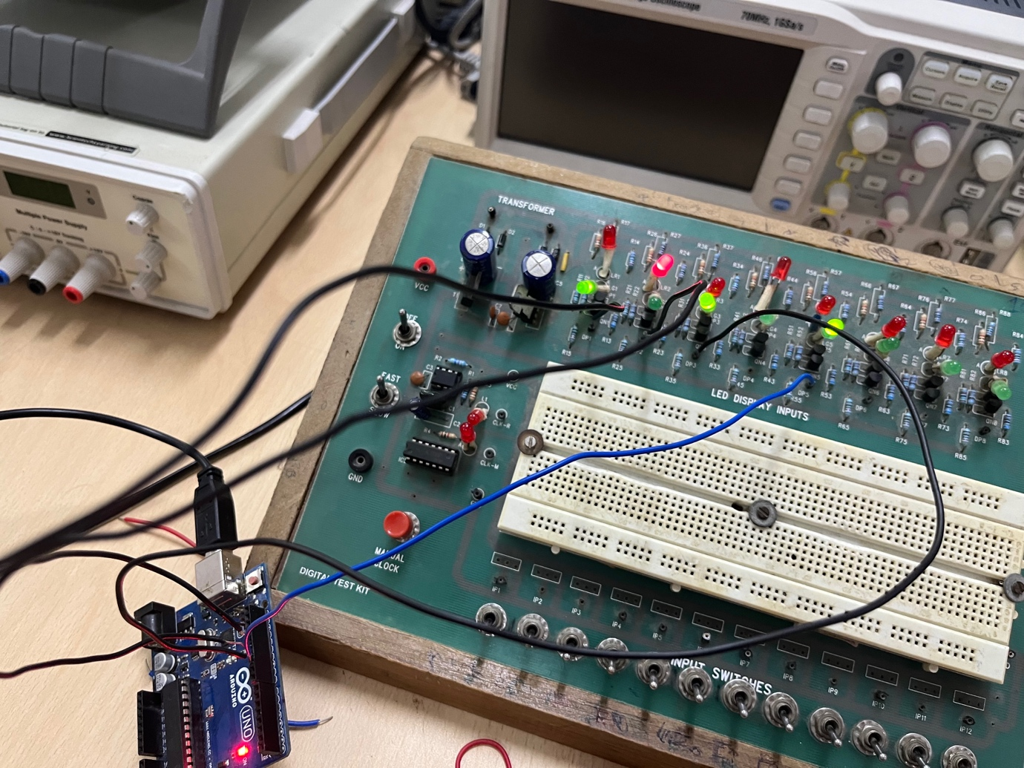

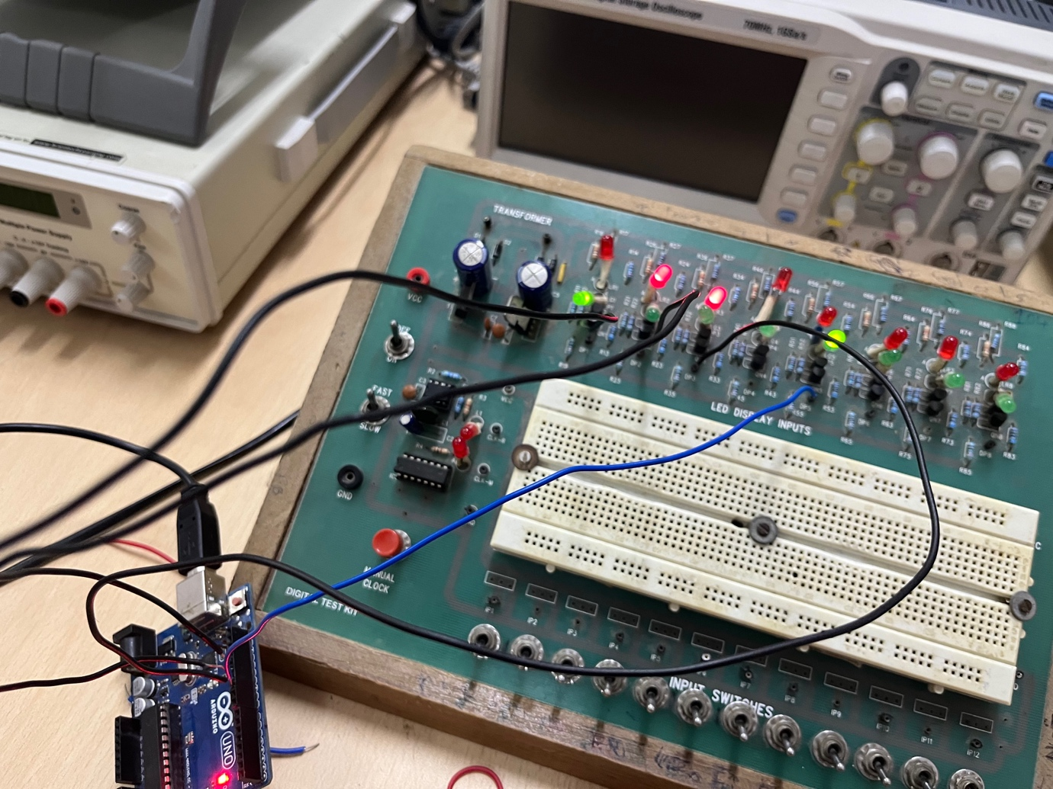

CONCLUSION:-

The up down desired counter is made using Arduino …

Experiment 6A:-

Objective:- To build a decade counter with a 7 segment display.

Electronic components required:-

1. Digital test kit
2. Timer (555 IC)
3. IC 74HC93 (4 bit binary counter)
4. IC CD4511 (BCD to 7 segment decoder)
5. 7 Segment display

TinkerCAD screenshot:-

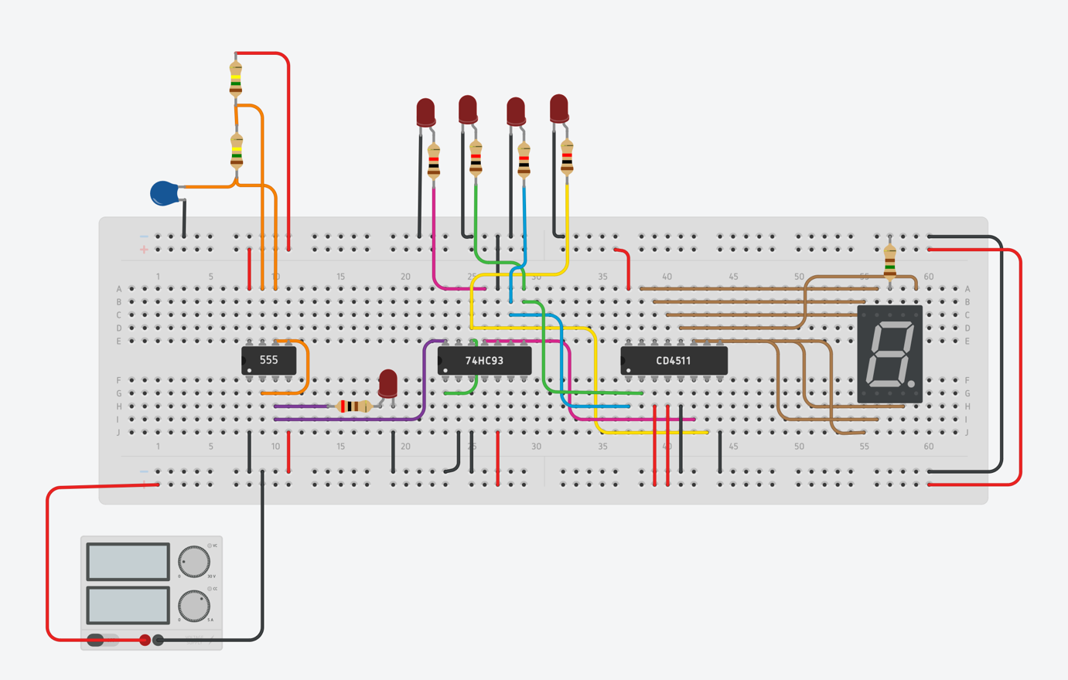

Reference circuits:-

\

Block diagram:-

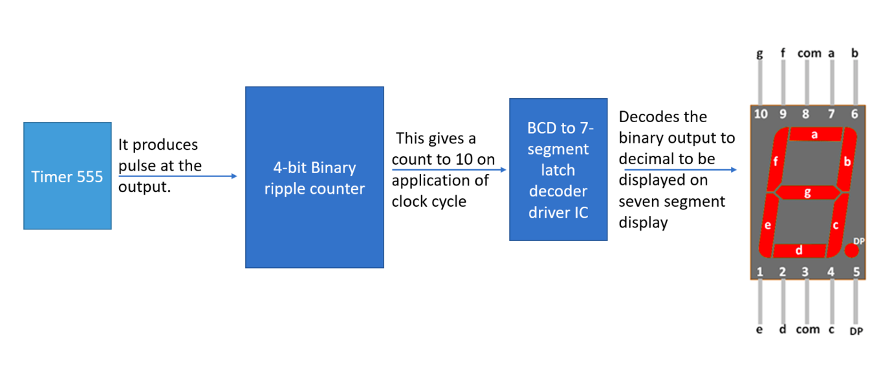

Procedure:-

1. Make appropriate connection to the timer (555 IC) to obtain a time pulse at the output.
2. Connect the output of 555 IC to Clock 1 and make connection to clock 0 appropriately in 7493..
3. Make the resets 0 and 1 to ground also connect power supply and GND of IC 7493.
4. Connect the output pins of 7493 to input pins of BCD convertor 4511 IC.
5. Make the common cathode display of 7 segment display and make appropriate of a,b,c,d,e,f,g from 4511 to 7 segment display..

Observation:-

The 7-segment display displays the numbers 0 to 9 then resets to 0 after 6 counts and repeats the process.

Conclusion:-

This is how we can make a 7 segment display that shows number from 0 to 9 …